Fundamentals of Programming

Lab Task #8

NAME : HAMAD ARSHAD

SECTION : ME -15-A

ROLLNO:481644

LAB INSTRUCTOR:SIR AFFAN

TASK 1:

#include<iostream>

using namespace std;

int main(){

int size,sum=0,avg=0;

cout<<"enter the size of array";

cin>>size;

int marks[size];

for(int i=0;i<size;i++){

cin>>marks[i];

sum+=marks[i];

}

avg=sum/size;

cout<<"THE AVG IS="<<avg;

return 0;

}

**OUTPUT:**

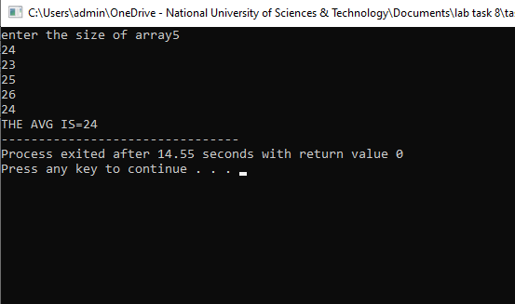

**TASK 2:**

**#include<iostream>**

**using namespace std;**

**int main(){**

**int arr[5];**

**int temp, i,j;**

**for(i=0; i<5; i++){**

**cout<<"Enter a Value: ";**

**cin>>arr[i];**

**}**

**for(i=0; i<5; i++){**

**for(j=0; j<5; j++){**

**if(arr[j]>arr[j+1]){**

**temp=arr[j+1];**

**arr[j+1]=arr[j];**

**arr[j]=temp;**

**} } }**

**for(i=0; i<4; i++){**

**cout<<arr[i]<<", ";**

**}**

**cout<<arr[4];**

**return 0;**

**output:**

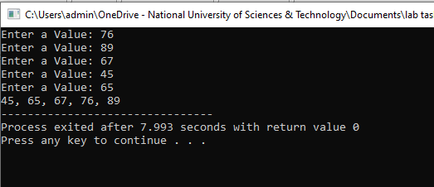

**Task 3:** **#include<iostream>**

**using namespace std;**

**int main(){**

**int arr[5];**

**int i,j, temp;**

**for(i=0; i<5; i++){**

**cout<<"Enter a Value: ";**

**cin>>arr[i]; }**

**for(i=0; i<5; i++){**

**for(j=i; j<5; j++){**

**if(arr[i]>arr[j]){**

**temp=arr[i];**

**arr[i]=arr[j];**

**arr[j]=temp;**

**} }**

**for(i=0; i<4; i++){**

**cout<<arr[i]<<", ";**

**}**

**cout<<arr[4];**

**}**

**return 0;**

**}**

